**DNS Host Record Discovery**

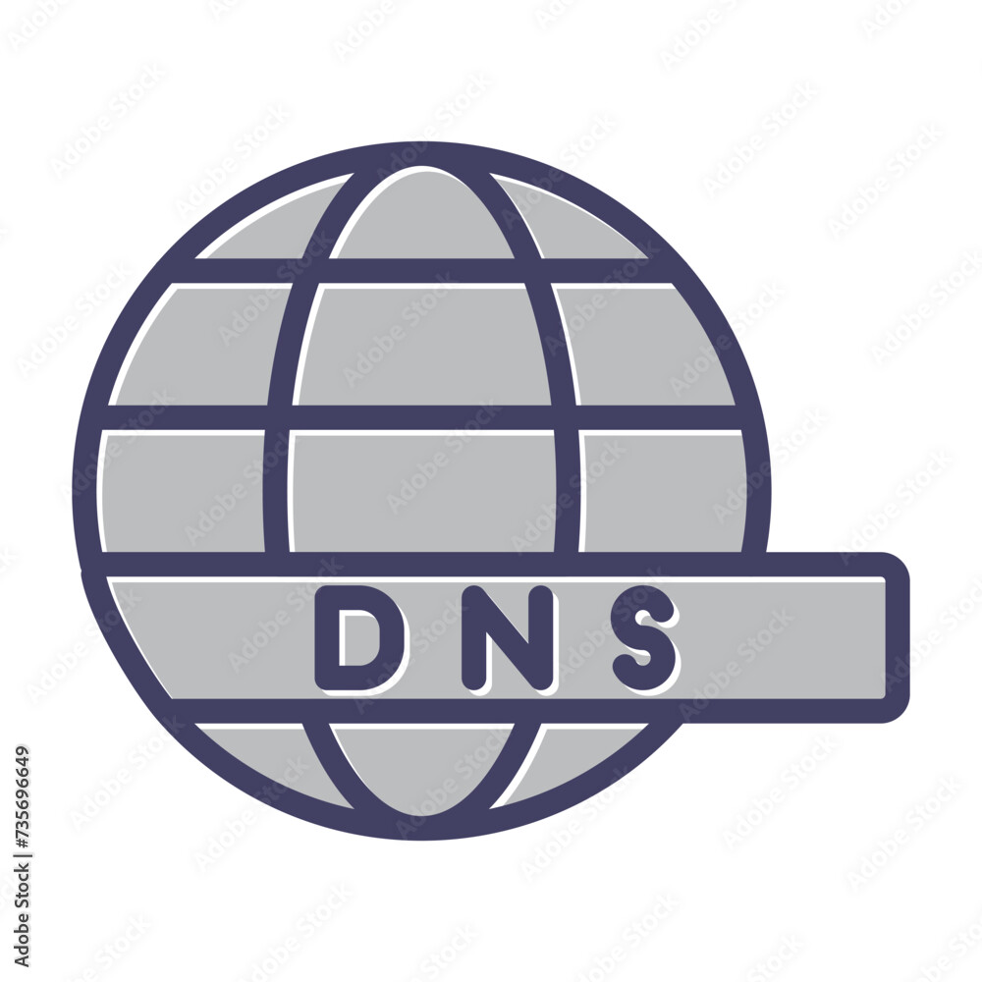

**1. Introduction**



DNS (Domain Name System) is a crucial component of the internet that translates domain names into IP addresses, allowing users to access websites and other resources using human-readable names. Understanding how to discover DNS host records is essential for network administrators and security professionals. This Capture the Flag (CTF) scenario introduces beginners to the basics of DNS host record discovery using the HackerTarget DNS Host Records Tool.

**2. Tools and Requirements**

HackerTarget DNS Host Records Tool: An online tool for discovering DNS host records.

<https://hackertarget.com/find-dns-host-records/>

**3. Scenario**

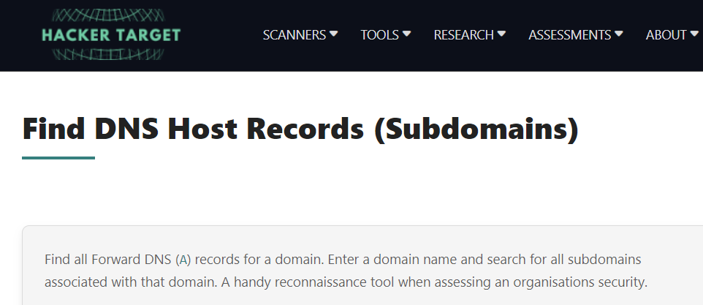



In this scenario, you will use the HackerTarget DNS Host Records Tool to discover host records for a given domain. Your tasks include identifying various types of DNS records, such as A, AAAA, CNAME, MX, and TXT records, to capture flags.

**4. Process to follow while performing CTF**

Step 1: Go to your browser and open the link:

<https://hackertarget.com/dns-lookup/>

Step 2: Search for this domain: facebook.com

Step 3: Go to the tools drop down menu and click dns lookup and type facebook.com

**Questions**

Flag 1: What is the IP address associated with the A record for facebook.com?

Answer: 157.240.229..35

Flag Captured.

Flag 2:What is the IPv6 address associated with the AAAA record for facebook.com?

Answer: 2a03:2880:f12f:83:face:b00c:0:25de

Flag Captured.

**Hint**

